**Activity 2**

Erick Grant

CSET, Grand Canyon University

CST-339: Java III

Prof. Sparks

October 1, 2023

**Part 1**

Figure 1- Part 1- Step 6

Figure 2- Part 1- Step 11

Figure 3- Part 1- Step 14

Figure 4- Part 1- Step 16

Figure 5- Part 1- Step 18A

Figure 6- Part 1- Step 18B

Figure 7- Part 1- Step18C

Figure 8- Part 1- Step 19B (Controller / )

Figure 9- Part 1- Step 19C (/Test2)

Figure 10- Part 1- /Test3

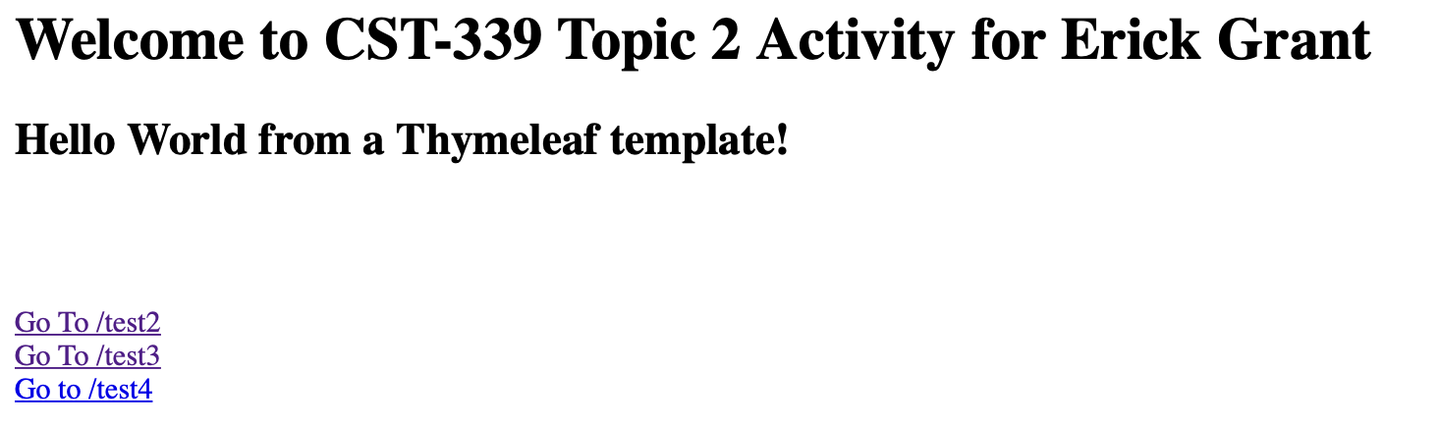

Figure 11- Part 1- /Test4

**Part 2**

Figure 12- Login Form Part 2- Step 13

Figure 13- Part 2- Step 21- Orders View

Figure 14- Part 2- Part 27- Bad inputs in login form

Figure 15- Part 2- Login form inputs are put into console

**Part 3**

Figure 16- Part 3- Finished Login Form with Layouts

Figure 17- Part 3- Finished Orders page with Layouts

**Research Questions**

1. How does Spring MVC support the MVC design pattern? Draw a diagram that supports the answer to this question.

The Spring-Model View-Controller supports the MVC design pattern in numerous ways, such as using the singleton pattern ensuring only one instance of an object exists inside of an application. It also uses autowired singletons, which means that the object ID inside the controller for a group is the same as the ID used in the controller for the single item. This is used in aggregation systems such as databases. The Spring MVC allows for external configuration, which means versatility such as templates can be used as well as behavior of a application. This is helpful to simplify the core application which increases speeds and decreases complexity.

Figure 18- Standard MVC (above) vs the browser-based Spring MVC (below)

2. Research and identify 2 MVC Frameworks other than Spring MVC. What are the frameworks and how do they differ from Spring MVC?

Ruby on Rails and Django are both very popular MVCs, they all have very large development communities and documentation. Ruby has a more readable language than Spring's Java and Object-Oriented based language. Spring tends to be more scalable and overall better performance. Ruby also tends to be more set-in stone, which can be helpful for finding suitable APIs but can be a bit of a hardship when applying the system to the development needs.

Django like Ruby imposes numerous constraints and gives less freedom to the developer, this can help decrease the risk of code works together incorrectly but increases the learning curve for the language. Spring is designed to mold to the needs of the developer as best as possible, this is helpful to allow Spring to be used in a very wide range of applications and this can increase confusion among developers as code may not work together as well as they would of Ruby or Django. Django requires more decision making in the development stage which can increase time and if the wrong decision is made more time can be spent fixing it.

References:

https://stackoverflow.com/questions/8547226/just-curious-to-know-the-difference-between-spring-mvc-vs-django